"All generations shall call me blessed." Luke 1:48

Holy Rosary Academy
Kindergarten - 12th Grade

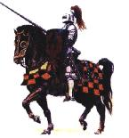

Parent / Student Handbook

1010 West Fireweed Lane
Anchorage, Alaska 99503

Office (907) 276-5822
FAX (907) 258-1055
E-mail: ewassell@gci.net

TABLE OF CONTENTS

HOLY ROSARY ACADEMY

The School Prayer
Introduction
Campus Map
Our Patroness
Emblem
Objectives

FOUR AREAS OF STUDENT LIFE

- Intellectual
- Moral
- Physical / Social
- Spiritual

EDUCATION

Faculty & Staff
Students

POLICIES

Admission Requirements
Pre-Admission Checklists
Labor
Athletics
Withdrawal
Diplomas & Transcripts

ACADEMICS

Academic Calendar
Daily Class Schedule
Final Grades
Homework
Curriculum

RULES OF LIFE

Student Rules of Conduct
General Regulations
Student Dress Codes
Uniforms

FEES AND REGISTRATION

Application Fee
Family Enrollment Fee
Tuition Fees
Miscellaneous Fees

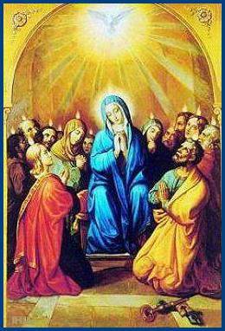

The School Prayer

Holy Spirit of God, abide with us;
Inspire all our thoughts;
Pervade our imaginations;
Suggest all our decisions;
Order all our doings.

Be with us in our silence and in our speech,
In our haste and in our leisure,
In company and solitude,
In the freshness of the morning
And in the weariness of the evening;
And give us grace at all times
Humbly to rejoice
In Thy mysterious companionship,
Through Jesus Christ our Lord. Amen

Through Jesus Christ our Lord. Amen.

INTRODUCTION

Why Catholic Education?

"..since education consists essentially in preparing man for what he must be and for what he must do here below, in order to attain the sublime goal for which he was created, it is clear that there can be no true education which is not wholly directed to man's last end, and that in the present order of Providence, since God has revealed Himself to us in the Person of His only-begotten Son, Who alone is "the Way, the Truth and the Life," there can be no ideally perfect education which is not a Christian education."

Pius XI, Divini Illud Magistri, 1929.

"Religion must not be taught to youth only during certain hours, but the entire system of education must be permeated with the sense of Christian piety. If this is lacking, if this holy spirit does not penetrate and inflame the souls of teacher and pupil, small benefit will be derived from any other sort of education; instead damage will be done. Almost every sort of training has its dangers, and only with difficulty will these be averted from growing youth, especially if divine controls are lacking which restrain their minds and wills."

Leo XIII, Militantis Ecclesiae, 1897.

"God and Jesus Christ, as well as His doctrines, were banished from schools [in Europe]. As a sad but inevitable consequence, schools becomes not only secular and non-religious, but openly atheistic and anti-religious. In such circumstances it was easy to persuade poor ignorant children that neither God nor religion are of any importance as far as their daily lives are concerned. God's name,

moreover, was scarcely ever mentioned in such schools, unless perchance it were to blaspheme and ridicule His Church. Thus schools, forcibly deprived of their right to teach anything about God and his law, could not but fail in their efforts to really educate, that is, to lead children to the practice of virtue, for the schools lacked the fundamental principles which underlie the possession of a knowledge of God and the means necessary to strengthen the will in its efforts toward good and in its avoidance of sin. And so there was no possibility of preparing the family and society true elements of order, peace and prosperity."
Pius XI, Ubi Arcano, 1922.

“Therefore, Catholics built their own schools, while paying taxes for non-religious schools, because they want their children to be educated in the love of Christ and his moral law, and thus to save their souls and become worthy citizens of their country.”
Archbishop Fulton Sheen

“The right of parents to choose an education in conformity with their religious faith must be absolutely guaranteed.”

“But corresponding to their right, parents have a serious duty to commit themselves totally to a cordial and active relationship with the teachers and the school authorities.”

Pope John Paul II, Familiaris Consortio

HOLY ROSARY ACADEMY
Campus Map

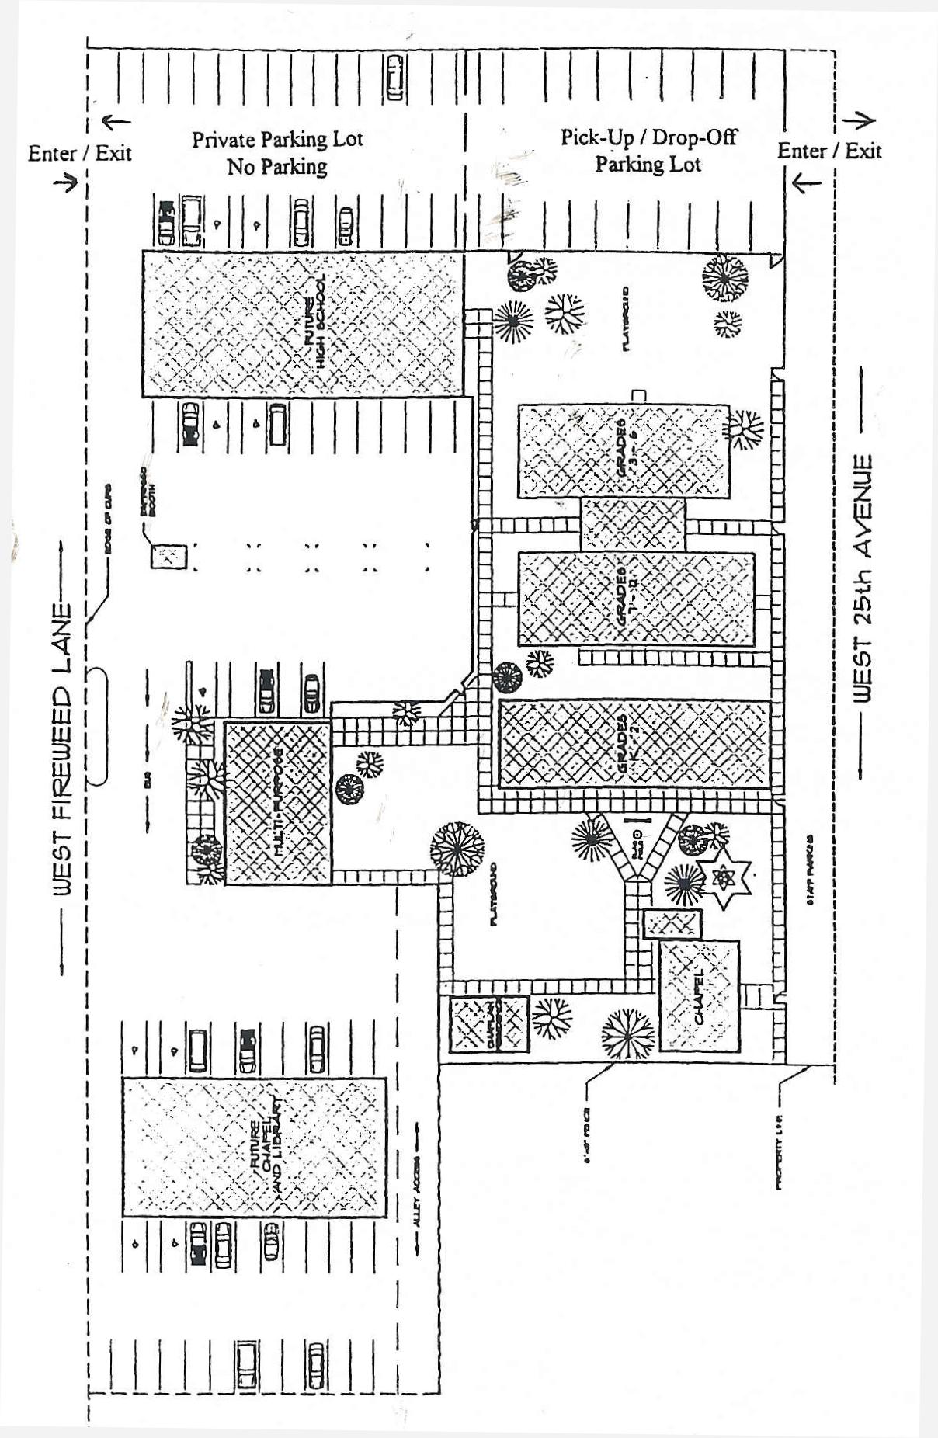

HOLY ROSARY ACADEMY

Our Patroness

Holy Rosary Academy was founded in the Marian Year 1987-1988, and was named in honor of Our Lady of the Rosary. The Blessed Virgin Mary is a wonderful exemplar for the dispositions necessary to learn the truth. When she is told that she will bear a son, she asks "How can this be, since I do not know man?" She responds with a spirit of wonder at God's power that has wrought this miracle inside of her. When the angel explains that she will conceive through the power of the Holy Spirit, she replies, "Behold the handmaid of the Lord; let it be done to me according to your word." She responds to God's invitation with humility and obedience. Without wonder, humility and obedience we cannot grow in understanding. We pray to God through the intercession of the Blessed Virgin to infuse these gifts in us.

Our Emblem

In 1994 the student body of Holy Rosary Academy chose as their emblem a knight. Since then we refer to ourselves as the Holy Rosary Knights. In former times, the knight of old would place his sword and shield at the altar of his Eternal King, and pray for strength and courage. As warriors for Our Lord, we follow the exhortation of St Paul: "Stand therefore, ..in all things taking the shield of faith, wherewith you may be able to extinguish all the fiery darts of the most wicked one. And take unto you the helmet of salvation, and the sword of the Spirit, which is the word of God" [Ephesians, c. 6, vv.14, 16, 17].

Christian Education at Holy Rosary Academy

Holy Rosary Academy is an independent school in the Catholic tradition, faithful to the See of Peter, founded and governed by Catholic laity. Founded in 1987, it comprises both grammar and secondary education. The Academy has as its mission the formation of the young in the intellectual and moral virtues which are the chief perfection of man.

Man comes into the world the most helpless of animals, and thus the most in need of nurture and education. Just as parents are the first to give life, so also they are the first to give instruction. As they grow older, the children need training in the arts and sciences, a task in which most families seek assistance. Hence the need for schools. A good education completes what the attentive parent has begun, continuing to foster the knowledge and habits they will need for their own lives and for benefit of civil society.

INTELLECTUAL FORMATION

The first purpose a true education must fulfill is the training of the mind. While moral formation is important, an institution that concerned itself exclusively with this to the detriment of the intellectual life would be unworthy to call itself a "school." The intellectual life has its object the consideration of the truth, and one trains the mind so that it may receive the truth more easily and more firmly. The pursuit of the truth, although useful is an activity carried out for its own sake. The truth is in itself wonderful and pleasant to behold.

Many if not most people think that education must be clearly "profitable" or immediately practical to be worthwhile. This view has changed education over the years; the traditional curriculum of the classics has been supplanted by programs that are more "useful" and "relevant." This lowering however of the goals of education has produced shallow educational system, which has produced students dismissive of what they cannot see as immediately practical for their "career." This cannot be surprising when one reflects on the fact that the best students are the ones who seek to know the most, not the least. And the more a school fosters wonder in its students, the more capable they become, not just in their career, but in whatever goal they set for themselves.

More importantly than this, we are more than "wage-earners"; we have souls that hunger to understand the world, its problems and its questions. We are citizens of a democracy who should act in light of our judgments about the common good. We are confronted with moral difficulties which mere pragmatism fails to address. While no education can give easy answers to the difficulties we face, it can offer the beginnings to the search. How do we do this?

In the grammar school, we teach the fundamentals - reading, writing, arithmetic, geography, history, catechism and science. In the high school, one perfects the tools they have received in the grammar school through study of the classic texts in each field - literary, philosophic and scientific. Whether the student is preparing for college or professional life, the study of great works give rigor and clarity to his thoughts and expression. broader

MORAL FORMATION

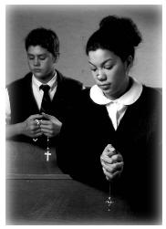
Along with planting the seeds of the intellectual virtues, our school also has as its end the fostering of the moral virtues. Here also, the work of the parents forms the foundation which schooling completes. Teachers can encourage and promote the good habits that parents have inculcated, deriving their authority from the consent of the parents for this end. Without the work of parents however, the school's ability to help the young to virtue will be faint and feeble.

How do we complete the moral formation that parents have initiated? From the youngest grades to the oldest, our students are required to be polite and charitable. They must take care of their appearance, keeping themselves and their school uniform clean and presentable. They learn to speak with respect to their elders, and with friendliness to their peers. Assigned chores teach responsibility, our gym and team sports programs encourage sportsmanship, and our clubs and social gatherings give them practice in organizing and moderating their own recreation and amusements.

PHYSICAL & SOCIAL FORMATION

As the students grow older, greater attention is given to explaining and defending moral behavior and the rules of etiquette. While the young cannot perfectly understand this reasoning coming as it does from experience and long tradition, without such explanation they will never come to understand right action. Literature and history classes, offering examples as they do of the best and worst in human action provide excellent matter for moral reflection. Without question however, the firmest foundation for moral instruction comes as part of the students courses in religion.

SPIRITUAL FORMATION

More clearly than elsewhere, it is religious instruction that calls the child to his proper dignity as a creation of God, made in His likeness and image, redeemed by the blood of Christ Jesus so that he may enter in perfect happiness in heaven. Hence, Pius IX wrote "it is proper to expect great things from a child who during catechism class learns that he is destined for a very high end in the vision and love of God." [In mezzo 72] Left merely to human standards, moral instruction ends in moral relativity, and "values" replace virtues. As Leo XIII pointed out long ago, "to want to have souls steeped in good morals, and at the same time to leave them deprived of religion, is as absurd as asking somebody to live virtuously after having undermined the foundations." [Affari vos, 159]

While religion strengthens the soul in the moral virtues, that is not its chief purpose. Religious instruction principally aims at nurturing the theological virtues of faith, hope and love. Education cannot effect these virtues, for they do not come from any human effort. Faith, hope and charity are the work of God's grace, chiefly through the sacraments of His Church. Hence, students are encouraged to pray and participate actively in the sacramental life, frequenting both Penance and the most Holy Eucharist. While profession of the Catholic faith is not required, all students are expected to join the community in prayer and religious instruction. These are not separable "parts" within a Christian education. Rather, the belief in a provident God, combined with our obligation to know and love Him is the animating spirit of any Christian education, and no less at Holy Rosary Academy.
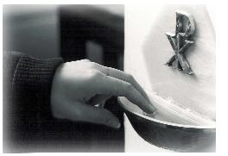

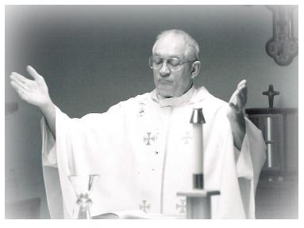

DAILY MASS SCHEDULE

Mass Times

Elementary School:
Middle School:
Senior High School:

CHAPEL DECORUM

Decorum, conduct and all aspects of student behavior in the Holy Rosary Chapel are governed by the Catholic belief in the “Real Presence” [Body, Blood, Soul and Divinity] of Jesus Christ in the tabernacle. The presence of Jesus in this special way makes the Chapel the most sacred and holy place on the HRA Campus. Thus student conduct in Chapel must always be reverent and reflective of that awesome presence of Christ Himself.
Following the example of Jesus Christ who took ordinary material things (bread, wine, water oil etc.) sanctified them, infused them with supernatural power in the sacraments and made them into visible outward signs of the faith, so too does the Roman Catholic Church elevate the ordinary material, visible, outward signs of the faith into sacramentals in the examples of the Sign of the Cross, relics, holy water, ashes etc. In this living tradition, Holy Rosary Academy maintains certain outward signs as a manifestation of an inward disposition of the soul towards reverence for the Eucharist and the Holy Sacrifice of the Mass. In addition Holy Rosary Academy would like to dedicate the use of these practices in some small way in reparation for the countless acts of irreverence committed against the Real Presence of Jesus Christ in the Eucharist. The specific traditional signs we incorporate are as follows:

Genuflection:
Upon entering and leaving the HRA chapel all students are required to genuflect. The Latin rite Catholic practice of genuflection is an acknowledgement of the presence of Jesus [“As I live, says the Lord, every knee shall bend before me….” Romans 14: vs. 11]. Catholics do this as an act of faith. Non-Catholics are expected to follow our practice out of respect for their Catholic brothers and sisters and for the sake of uniformity but not as
an act of faith.

Head Coverings:

All female students will wear chapel veils as part of their school uniform while in the chapel. Male students will keep their heads uncovered while in the chapel (any hats or head coverings are to be removed). The traditional use of a Chapel veil by women is meant to convey a sign of respect and adoration to Almighty God present in the tabernacle. On the other hand men have traditionally shown that same respect and adoration by the removal of their hats. Holy Rosary considers this practice a helpful one in teaching students about the Real Presence.
Reception of Holy Communion:
Students will receive Holy Communion while kneeling at the Communion Rail. In the Latin Church, kneeling has been the traditional sign of showing adoration towards God. Holy Rosary’s Chapel was constructed with a communion rail in order to give students an experience of this traditional form of reverence while receiving Holy Communion. Also because of narrow spaces in the chapel, the use of the rail facilitates a smoother traffic flow.

Reception of Holy Communion on the Tongue:
Holy Rosary maintains Holy Communion on the tongue as the normal practice. Use of the communion rail mitigates against communion in the hand, particularly with smaller children – the rail being perhaps at chin level. This is also helpful in teaching the students respect for the Real Presence, as students sometimes become careless when receiving in the hand. As some students may prefer to receive communion in the hand when in their own parishes, Holy Rosary Academy will spend time reviewing the correct technique for doing so in all classes of religion.

EDUCATION

Faculty, Staff
and Students



FACULTY AND STAFF

As Pope John Paul II has said, the task of education belongs primarily to parents, but requires the help of society, namely educational institutions. If the institution is to fulfill its end in the overall formation of the student – Nurturing, fostering and developing virtue; preparing them for all aspects of life; providing friendship and leadership—then contact inside and outside of class must be made between the students and faculty and the staff. All members of the school community must take part in the whole education. To do this, the faculty and staff must be able to teach by example as much as by word. It must be kept in mind that students learn best through example.

Therefore, all faculty and staff are teachers generally, regardless of their particular duties and must “bear testimony by their lives and their teaching on the one Teacher, Christ.” (Vatican II, Declaration on Christian education, Chapter 8) Also, faculty and staff must be willing to work in close contact and co-operate with the parents to protect the rights of both parent and student. The faculty and staff, because of their commitment as Catholic lay apostles, will be able to lead the students in all areas of education, not solely in their own expertise.

The faculty of the school is charged with the primary duty of teaching in the integrated curriculum and of making themselves as competent as possible in their place as teachers. They should keep in mind that they will have an impact on students far greater than most because of the amount of time they spend with the students.

EDUCATION - STUDENTS

The students are the chief beneficiaries of the school and so have certain responsibilities. They have a duty to study in a diligent manner and to conduct themselves as Catholic ladies and gentlemen in accordance with the laws of the Catholic Church, the laws of the State and the rules and regulations of the school.

Students of the school are those who have duly registered, have been admitted and are in good standing with the principal and executive director.

All extracurricular activities devised or sponsored by the students and / or their parent shall be judged by the principal as to their propriety and their agreement with the general purpose and programs of the school, particularly when they are done in the name of the Academy.

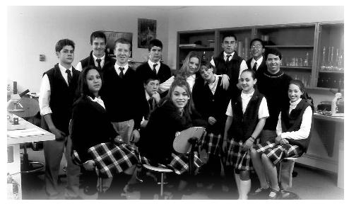

ADMISSION REQUIREMENTS

Academy will accept new students in grades K-8. High school transfer students are a rare exception and Holy Rosary Academy does not discriminate on the basis of race, color, sex, or national origin. However all students are required to participate in the entire program of studies and activities.

The type of students desired are those whose parents desire academic excellence and formation of their children in a school that is faithful to Holy Mother Church and the teaching Magisterium.

Although it is preferred that all students begin our integrated program of studies in the early primary grades, sometimes this is not possible. Therefore Holy Rosary must demonstrate to the Principal a good academic background and character that is docile and in tune with this program of studies before admission will be granted.

PRE-ADMISSION CHECKLIST

- An application form must be completed with a non-refundable application fee of $50.00 attached.

- Complete and current records from previous schools attended must be submitted along with any scores from achievement tests.

- Medical records and a physical examination report by a certified doctor are required.

- Signed acknowledgement of the Parent / Student Handbook.

- A complete student information packet filled out by parents that is supplied by the school.

- A financial agreement must be signed with a non-refundable enrollment fee of $100.00 in place.

- All students in grades 7-12 are required to fill out and sign a student covenant with the school.

8. All students applying for grades 7-12 must pass write an essay of a minimum of 300 words stating why they want to attend HRA and be interviewed by either the Principal or Executive Director.

LABOR

A distinct feature of community life at Holy Rosary Academy is the commitment of each member to the notion of Happy Labor. This means working a few hours a week at some service to the school, be it in the classroom or helping with maintenance. Happy Labor not only allows for direct participation in community life and fosters a sense of responsibility, but also reduces the overall costs of the school so that those who desire such an education can have it, regardless of financial background.

Also labor is a reality and a good. It must be seen, not as a result of the Fall, but as a law given to us by God and as a means of sanctification, perfection and fulfillment. All labor should be directed at developing in the student a sense of duty to God and society, and also towards developing the student’s own capabilities and talents in preparation for a future vocation.

The student initially learns this sense of duty by performing simple daily tasks like studies and chores. In offering up these tasks to God, through initiation of God’s creative power, and by bringing these duties to their fruitful end, the students are able to perfect and fulfill themselves through labor. Labor becomes prayer.

Thorough labor the student also learns to be an active, contributing member of the community, whether church, civil society, school or family. A careful performance and love of work allows the student to exercise and develop the body to build character, to increase capacities and to uncover talents, while receiving training in useful necessary skills. This prepares the student to assume the responsibilities of adulthood.

Thus, labor is essential for the completion and perfection
of both supernatural and human qualities in light of the
Christian understanding of man.

ATHLETICS

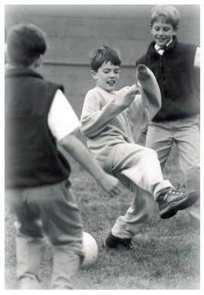
Due to a loss of the true meaning of athletics, the overemphasis of the importance of sports activities, and the general sense of passivity that many students have towards athletics, students are encouraged to participate in intramural programs offered by the school. The athletics is aimed at instructing the students in the basics of various sports, engaging the students in active participation and encouraging the students to help organize activities. This develops responsibility, imagination, initiative and leadership. Competitive sports such as basketball, volleyball, soccer, softball and cheerleading are also available to junior high and senior high school students each year.

Man is body and soul. Total education requires proper balance between the developments of these two essential parts. This balance requires that the body, as well as the mind and spirit, be nurtured. Sports and recreation are crucial aspects of the formation and development of young people. Athletics is a means of using and developing the body, which also frees the soul to perform all its functions better.

Athletics teaches the student to respect the body as something noble and good since it is a God-given gift and a temple of the Holy Spirit. Sports activities, done in common and in a spirit of charity, allow for the development of the qualities necessary for adulthood and true social friendship. Also, participation in disciplined ordered activity allows the student to learn the importance for rules and regulations in all areas of life.

COMMUNITY & SOCIAL LIFE

Social life is community life, living in common and in friendship. A person is not complete until he is one with God, neighbor and self. Community life, therefore, is education in friendship. As a member of a community, the student learns that friendship is the result of what people hold in common and what they do to bring about the common purpose. The common purpose at the school is love of God, neighbor and self as commanded by Christ Himself.

The qualities that mark true friendship are respect, civility, decency, manners, right language and moral behavior. These qualities are developed through common activities such as living, studying, dining, labor, sports and prayer. It is in these activities that we come to be true friends.

Special events will take place during the year in order to fulfill the totality of education. Certain activities will aim at exposing the students to their cultural and religious heritage. These activities will include trips to museums, places of historical significance, libraries, art galleries, concert halls etc. Also, trips will be taken to the mountains and countryside when possible. Holy days and holidays will be celebrated with activities appropriate to the meaning of the day.

WITHDRAWAL

Within 30 days of the beginning of the school year, families may receive a full refund of tuition less $500.00 if all books and lessons are returned in new condition. Cost of used materials will be deducted from the refund.

After 30 days, the families will be charged full tuition. Those families using a monthly tuition plan are still obligated to pay full tuition after 30 days even if they choose to withdraw or are expelled from the program.

DIPLOMAS & TRANSCRIPTS

Holy Rosary Academy is fully accredited by the State of Alaska and provides High School diplomas to those students who meet and pass all the necessary requirements. On leaving the school, each student is entitled to one transcript of their academic record, free of charge, if their financial obligations to the school have been fulfilled. For each additional transcript there will be a $25.00 fee.

ACADEMICS

Academic Calendar
Daily Class Schedule
Final Grades
Curriculum

ACADEMIC CALENDAR

A calendar for the academic year will be published and posted for each year prior to the Fall semester.

- Classes are held on the days posted on the academic calendar.

- Teachers and students are to be punctual in beginning and ending classes at the scheduled time.

- An examination schedule will be drawn up by the Principal for each semester for grades 7-12.

- All teachers will keep a current record of each student’s grades and attendance.

- All students are required to make up all work missed during their absence within a few days. If a student misses more than 6 days of school per quarter, then academic credit may be withheld at the principal’s discretion.

- An unexcused absence or three unexcused tardies warrant disciplinary action by the Principal.

7. Students who are not in there classrooms and prepared
for the day before morning prayer are considered tardy.

DAILY CLASS SCHEDULE

Kindergarten – Grade 6

7:30 – 7:45 Students arrive and prepare for classes
7:45 Morning Prayers
8:00 Classes begin
3:00 Dismissal

Grades 7 - 12

7:30 – 7:45 Students arrive and prepare for classes
7:45 Morning Prayers
8:00 Classes begin
3:00 Dismissal

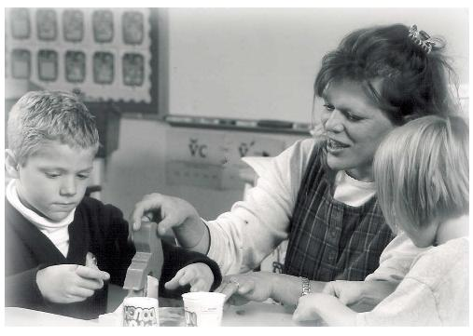

FINAL GRADES

- In computing final grades for each quarter, all teachers are to take into consideration a student’s daily academic achievement, preparedness, tests quizzes, reports, notebooks and exams.

- Final grades will be entered on Progress Reports and sent home to parents after each quarter.

- Students in grades 7 – 12 shall receive semester grades as well as quarter grades each year. The semester grades are an average of their quarter grades and will show on their permanent record.

GRADING SCALE
Letter Grade  A+  A  A-  B+  B  B-  C+  C  C-  D+  D  D-  F (no credit) | Percent Scale  99-100  95-98  93-94  90-92  87-89  85-86  82-84  79-81  77-78  75-76  72-74  70-71  69 or below | Grade Points  4.0  4.0  3.7  3.3  3.0  2.7  2.3  2.0  1.7  1.3  1.0  0.7  0.0

HOMEWORK

Students in grades 1-3 should have minimal homework. Work should be done in class with the supervision of the teacher. However, any unfinished work should be done at home and returned the following morning.

Students in grades 4 – 6 should expect 1 to 1 ½ hours of homework daily, including ½ hour of math and ½ hour of reading.

Students in grades 7 – 12 will have an average of 1 – 2 hours of homework. (½ hour math; ½ hour reading; ½ hour language and ½ hour for papers, projects and unfinished assignments).

All work is expected to be turned in on time – no exceptions. Points will be deducted for late work.

Homework falls under the learning of self-discipline, something of which there is too little in today’s society. This self-discipline will eventually be a great asset to all Holy Rosary Academy students. We encourage all parents to support this effort by supplying and encouraging quiet academic time each evening in the home.

ACADEMICS & CURRICULUM
The Grammar School

Our grammar school imparts the fundamentals of learning.

Religion
Arithmetic
Geography
Grammar, Penmanship, Phonics, Reading &
Spelling
History
Natural Science
Art
Physical Education

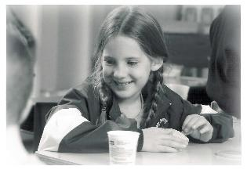

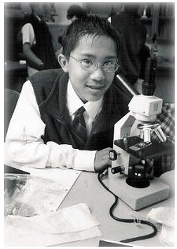

ACADEMICS & CURRICULUM
The Middle School

The proximate task of the Middle School is to perfect the fundamentals the students have received from the primary grades. The Middle School is then the crowning part of the grammar school. The demands made of the students at this point however are much greater. They are now capable of understanding history, religion, literature and their other subjects in more mature fashion. They question what they learn in a way they could not at first, and now the training of the memory must go hand in hand with the training of the understanding.

Thus, the Middle School provides an important transition between the primary grades and the High School. The High School curriculum presumes one has the power to read difficult texts and analyze them. The student must know how to outline readings, frame questions, summarize lectures and express his thoughts in speech and in writing. Our Middle School has then as its ultimate task to provide the students with necessary habits to receive the maximum benefit from the High School program.

Middle School Year I

Latin I: Oxford Latin Course
Pre-Algebra
Literature & Composition: Concentrates on the mastery of the parts of speech, parts of a sentence, development of narrative, and descriptive and chronological paragraphs. Literature readings include: Murder in the Cathedral, Robin Hood, Cyrano de Bergerac, The Last Battle Dr. Jekeyl and Mr. Hyde, and Tales of the Greek Heroes.
History: Christ the King, Lord of History
General Science
Religion: Faith and Life Series The Life of Grace
Music & Art (depending on teacher availability)

Middle School Year II

Latin II: Oxford Latin Course
Algebra
Literature & Composition: A continuation of the previous course with the addition of the essay form. Readings include: The Miracle Worker,
A Christmas Carol, The Scarlet Letter, The Pearl The Old Man and the Sea British & American Poetry, Huckleberry Finn
History: “Christ In The Americas”
General Science
Religion: Faith and Life Series “Our Life in the Church – The Story of the Church”
Music & Art (depending on teacher availability)

ACADEMICS & CURRICULUM
The Secondary School

The principal end of the academic program is the reception of the intellectual virtues or excellences of mind. This comes through mental training, forming mind, memory and imagination to work together in an orderly and efficient way. This will not come through a chance arrangement of subjects, nor will it come through any choice series of books.

As much as possible, our secondary school curriculum draws from the classics of Greek and Roman writers. These texts prepared the best minds of the ages in schools both secular and religious for over a thousand years. It seems almost a platitude to remark that the better books one reads, the stronger one's mind becomes; yet our contemporary schools have resigned themselves to teaching from inferior books by mediocre scholars. In the name of giving students books they can better understand, their understanding is dulled.

The primacy of the classical curriculum has limits. William Shakespeare is not a Greek writer, yet he is important for seeing the beauty of our own language. James Madison is not a Roman writer, yet is he important for understanding the strengths and weaknesses of our peculiar form of government. Even so, both authors presume knowledge of the classics, and an immersion in those classics reveals many hidden depths in the great minds who come after.

Where the subject matter is exceptionally difficult or current inquiry makes earlier treatments obsolete, modern texts will be both necessary and useful. Such texts predominate more in the sciences than elsewhere. Yet, even there, the classic writers who founded the sciences we study have many lessons for us, and we will not be worse off for knowing them.

An Explanation of the Courses

Each of the courses within the curriculum contributes the training of the mind in different ways. In what follows, the purpose and importance of each required subject within the high school curriculum is explained. This is followed by a list of the texts for each course. This list should not be taken as exhaustive, nor immutable from revision.

Literature & History

Nothing helps to understand man today as much as a profound study of history. Good judgment demands experience, and good political judgment demands a knowledge of past laws and regimes. When one reads our Founding Fathers, it is impossible not to be impressed at the depth of their reading in Greek and Roman histories, and the kingdoms and republics of their own time. This reading began in their early years, and grew into the political wisdom, which we admire and from which we still benefit. Further, the deeds of great men provide examples for instruction and emulation. As Plutarch says, virtuous action "can so affect men's minds as to create at once both the admiration of the things done and desire to imitate the doers of them."

We often delight in works of imitation - stories and poems, speeches and plays - without knowing why. While one may recognize the importance of our emotions in the enjoyment of the imitative arts, a literature course that remained entirely on the level of individual "feelings" would trap the student in his own private world. Great literature stands the test of time precisely because it reveals the world to us in a wonderful and profound way. The courses in literature shows the student how to find the underlying patterns and devices that make a work beautiful. Further, in conjunction with this analysis, the student also learns how to express his own thoughts clearly and persuasively, both in speech and in writing. Indeed, the finest works of literature provide the best exemplars for self-expression.

Grade 9 Humane Letters Seminar I: US History & American Literature is studied. Readings include The Declaration of Independence, The Constitution, selections from the Federalist Papers, Billy Bud, To Kill a Mockingbird, Walden, & Civil Disobedience, The Jungle & American Poetry.

Composition: Writer’s Seminar – Literature, Structure, Sound & Sense - Vocabulary

Grade 10 Humane Letters Seminar II: Modern European History & Literature are studied. Readings include: A Tale of Two Cities, Pride & Prejudice, “The Social Contract” Socialism, “The Communist Manifesto” Crime & Punishment & others.
Composition: Writer’s Seminar – Writing focuses on the formal essay - Literature, Structure, Sound & Sense - Vocabulary

Grade 11 Humane Letters Seminar III: Integrates theology, philosophy, literature and history. The focus on the Greek, Roman and early Christian period. Authors include Homer, Aeschylus, Sophocles, Plato, Aristotle, Thucydides & Virgil. Disciplined writing is an integral part of this course.

Composition: Writer’s Seminar – poetry & Vocal

Grade 12 Humane Letters Seminar IV: Integrates theology, philosophy, literature and history. Readings are drawn from Medieval to Modern periods in European history and literature. Classical texts in the theology of the Reformation are studied. Authors include: Augustine, Aquinas, Luther, Machiavelle, Montaigne, Descartes, Cervantes, Rousseau, Hegel & others.

Composition: Writer’s Seminar Disciplined writing is stressed.

Language

While ancient Greek and Latin are rarely spoken, many reasons compel its inclusion in secondary instruction. First, our own language borrows heavily from these languages, most especially in technical fields such as law and medicine. Second, both Greek and Latin are inflected languages, languages where nouns take on different endings as a function of their gender, number and case. This allows the student to grasp the principles of grammar more firmly, and through a foreign language, better understand the structure of his own. Finally, the knowledge of Greek and Latin allows the student to encounter the writings of Plato and St John the Evangelist, Caesar and St Thomas Aquinas in their own tongue.

Grade 9 Latin III
Grade 10 Latin IV
Grade 11 Modern Language Choice
Grade 12 Modern Language Choice

Unfortunately, until Dr. Hippler returns or a suitable replacement is found we are unable to offer Greek.

Mathematics

Both modern science and modern technology demands a strong background in mathematics. Even apart from its application, it is useful for training the mind through the rigor of its method. Here one first finds definitions, proofs, postulates and axioms. Here one must order the known in such manner that one can discover the "unknown." Mathematics is hence crucial for showing the student the attributes of demonstrative reasoning. Finally, mathematics reveals truths that are wonderful -the geometry of Euclid. The properties of triangles, circles, parallel lines and conic sections continue to amaze and delight the mind.

Unfortunately, until Dr. Hippler returns or a suitable replacement is found we are unable to offer Euclidian Geometry.

Grade 9 Geometry
Grade 10 Pre-Calculus
Grade 11 Calculus
Grade 12 Advanced Mathematics

Religion

Since religion has as its subject God, known with the greatest certitude through faith, these courses occupy an undisputed primacy within the curriculum. God cannot be excluded as a subject for reverent study without implying that He is either non-existent or unknowable. Hence the prophetic words of Pius XI: "..the so-called 'neutral' or 'lay' school, from which religion is excluded, is contrary to the fundamental principles of education. Such a school cannot exist in practice; it is bound to become irreligious." [Divini illud Magistri, 290]. Let no one think that in religion, sentiment or "opinion" replaces careful study and reasoning. Here also the intellect is trained, both in the examination and defense of Christian belief. One cannot prove the articles of faith, but one can show that assent to them is reasonable. The study of revealed truth shows the beauty and harmony of the Christian faith.

Grade 9 CCC Catholic Morality & the Creed
Grade 10 CCC The Sacraments – Survey of
The Bible
Grade 11 CCC The Commandments – the Call
Of God – Priesthood, Consecrated
Life or Marriage
Grade 12 CCC Prayer – Life Issues & Senior Thesis

Science

A complete education must needs include the study of nature. We tend to describe as "natural" everything apart from man, oftimes thinking of nature insofar as it serves our needs. More than this, natural science helps us understand ourselves. Our own bodies are like little worlds, embracing the qualities of chemical substances, plants and animals. For us to neglect nature would be to neglect knowing ourselves. Furthermore, man depends in different way on all these grades of nature; they are all in some way causes to Him. The study of nature shows her power, but also her limitations. By following the chain of causes in a spirit of wonder, we see what scientists such as Newton and Einstein have argued through the ages, that nature is not sufficient to explain herself, that one must resolve to a First Cause beyond the natural world we experience. In the words of the Psalmist, "The heavens proclaim the glory of God, and the firmament declares the work of his hands."

Grade 9 Biology
Grade 10 Chemistry
Grade 11 Physics

Character Class

This class meets five times in the course of the semester. While the religion classes offer moral instruction, young adults often have situations that demand particular focus and attention. This demands a more particular application of moral principles given in general form elsewhere. They have heard of bravery, but they also must hear how to follow their conscience even against the pressure of peers. They have learned about temperance, but they also must learn the importance of sobriety, purity and modesty. They have studied justice, but they must also study the damage to themselves and others from lying, stealing and cheating.

Etiquette

This is a semester class that meets once a week. Politeness is not the same as morality, but a logical extension of it. Certainly, a genuine love for others demands that we learn the forms and practices that show respect for the feelings of others. Some consider rules of etiquette a weapon for social elite to tyrannize others; the exact opposite is the case. Students learn these rules so that as they move in the adult world, they will treat their fellow men with the goodwill that is their due.

Music Theory and Appreciation

In conjunction with the musical training that students receive within the choir, they will also be instructed in the fundamentals of music notation and history. Music more than any other art form displays the importance of beauty in human life; people who may be passionate about no other form of art will have some feeling for music. This course will manifest the latent structures within music, and provide some principles for distinguishing good music from bad.

Writing and Composition

Writing is an art that is acquired through practice. It helps us to clarify and analyze our ideas in a way nothing else can. For this reason, writing is not merely a course within the literature department, but is an important part of every subject. Students are expected to write three term papers every quarter, which will be distributed throughout their various courses. These papers count for twenty-five percent of their semester grade. Regardless of subject, all papers will be graded on grammar, spelling and usage as well as content. All papers are to be typed, except at the teacher's discretion. All handwritten assignments must be legible and in good English. Students should own a dictionary and a thesaurus.

The Senior Thesis

In their senior year, students each choose a topic from a required course, and compose a 5000 to 6000 word essay which advances some thesis on that topic. This paper proceeds argumentatively; that is, the paper should include objections against the student's position, an explanation of that position, and a resolution or reply to the objections. Toward the end of the year, the student will defend the thesis before the faculty in a public examination open to all. The senior thesis and the defense should manifest the student's acquired ability in expression and argument.

RULES OF LIFE

Student Rules of Conduct
General Regulations
Student Dress Code
Outdoor Clothing

School regulations are planned for the mutual good of the school and the students. Admittance to the school indicates acceptance of these regulations by the parents and the students.

STUDENT RULES OF CONDUCT

- Holy Rosary Academy has a zero tolerance policy regarding the use or possession on campus or during school events of alcohol or illegal drugs. Violation of this policy always results in either immediate expulsion or a suspension of 10 days at the discretion of the Principal and Executive Director. Although Holy Rosary cannot and does not intend to police the lives of students in their after school life, nonetheless, such conduct is neither compatible with the Catholic Faith or Holy Rosary Academy.

- Possession of tobacco is not allowed

- Personal hygiene, health, cleanliness and neatness must be observed at all times.

- Proper hair length must be maintained at all times for gentlemen. This means the ear must be completely visible, and that the hair must not touch the nape of the neck. Proper hair styles are to be observed by all students. All gentlemen are expected to have regular haircuts and be clean-shaven. No beards or mustaches

- Attendance is required at all scheduled events.

- Gentlemanly and ladylike conduct is to be observed at all times. This means no stealing, cheating or plagiarism. No disrespect, immoderation, immodesty will be allowed. Gentlemanly and ladylike applies to language and obviously precludes foul or vulgar mannerisms of speech.

- No pets are allowed at school.

- No weapons are allowed at school.

- Steady dating or steady company keeping is not permitted on school premises.

- No earrings for boys or body piercing by any student are allowed.

- Tattoos are not permitted.

GENERAL REGULATIONS

- All students as indicated must observe Holiday schedules on the school calendar. Families should plan their vacations such that students do not miss any scheduled school days.

- Appointments with dentists and doctors should be arranged to take place during vacations or after school hours.

- Students will not be called to the phone during class or study hours nor be allowed to use the phone unless there is an emergency.

- Students are not permitted to have automobiles on campus or in neighboring garages without the express permission of the Principal.

- The possession of radios, cell phones, or electrical appliances is not allowed.

- Destruction of school property will be charged to those responsible for the damage.

- Students are held accountable for their conduct during weekends and vacations and are liable for any actions that reflect on their character or the good name of the school. School authorities reserve the right to terminate a student’s affiliation with the school if he or she is unsatisfactory in either studies or discipline.

- Discipline: Appropriate disciplinary measurers will be taken by the Principal or Executive Director when necessary. This may mean detention, suspension, or expulsion for academic or serious behavioral problems.

a.) Detention Policy: Students who commit minor infractions, whether they are academic, behavior or otherwise, will be assigned a one-hour detention the following day[s] from 3:00 – 4:00 PM. School will supervise all detentions
and will be served at school. Major or repeated infractions will result in Saturday 9:00 AM to 12:00 Noon special in-uniform detention.

b.) Suspension Expulsion Policy: Meeting academic and attendance requirements is not sufficient to maintain successful progress through the school. It is expected that students conduct themselves as ladies and gentlemen. If a student does not conduct himself or herself properly, he or she
may be suspended between one and five days at the discretion of the principal. Three suspen-sions result in automatic expulsion. On days of suspension students receive no academic credit.

c.) Punctuality Policy: As part of a student’s self-discipline, punctuality in morning arrival, class attendance and academy functions are required.

If a student is late for the commencement, class attendance and academy functions more than two times during a quarterly period he or she will be required to serve a 60 minute detention from 3:00 to 4:00 PM on the afternoon of the second incident.

Students arriving late for school will immediately report to the main office for an admittance pass prior to class attendance.

Students arriving late for classes or academy functions scheduled throughout the day will not be permitted attendance without first submitting a valid attendance pass issued by the main office to the teacher or function coordinator.

Students will be considered habitually late at the occurrence of the ninth late arrival during a quarterly period. Parents of the students will be required to meet with the principal to remedy the situation immediately or face suspension or possible expulsion.

Teachers are required to strictly observe and monitor punctuality in accordance with this policy.

In situations of extenuating circumstances, (such as foul whether or personal emergencies) this policy may be waived by the judgment of the principal.

UNIFORM POLICY

Students are to arrive at school and leave at the end of the day in uniform.

Students reporting to class in improper uniform will be sent to the office. A call will be made to the parents and the student will return to class only when the proper uniform is brought to school.

GENTLEMEN: Grades K – 12

White dress shirt (button down collar)
Green V-neck sweater
Black or Khaki uniform slacks
Black Belt
School tie
Black shoes that can be polished

LADIES: Grades K – 6

White blouse
Green cardigan sweater
Plaid jumper or skirt (length to be at the knee –not above)
Tights, anklets, or cotton knee socks (white, navy or black only)
Khaki uniform slacks (optional) Skirts must be worn on days students attend Mass

LADIES: Grades 7 – 12

White blouse
Green cardigan or V-neck sweater
Plaid skirt (length to be at the knee –not above)
Tights, cotton knee socks or nylons (white, navy, black or nude only)
School tie optional

Ladies in grades 9–12 may wear make-up and clear nail polish only. Jewelry may be worn in moderation – No piercing except single ears.

OUTDOOR CLOTHING

WINTER CLOTHING K-6

Coats, snow pants, boots hat and gloves
Students who do not have proper outdoor clothing may not participate in outdoor recess activities.
Clothing for Spring & Fall Months K – 6

Sweatpants may be worn on top of school clothing during recess time for the months of August September, April and May.

P. E. APPAREL Grades 1-12

All students will need to purchase a school gym uniform from the school office and should come to school in their gym uniforms on their scheduled P. E. day in order to participate. Students must wear white socks and gym shoes with these uniforms. The gym uniform includes pants, jacket, shorts and tee shirt. Students who are not properly dressed will not be allowed to participate and will be sent home. Exceptions to this rule are to be made at the discretion of the principal.

Students who arrive at school unprepared for class, or are improperly dressed or groomed will be sent to the office and their parents will be contacted in order to correct the situation.

FEES & REGISTRATION

Registration Fees

Enrollment Fees
Tuition

HOLY ROSARY ACADEMY

TUITION PAYMENT PLAN
2002 – 2003

An Annual Enrollment Fee of $100.00 per student is due before your child (ren) is/are duly registered. This fee is non-refundable and must be paid before your child (ren) begins attending classes.

I understand when full tuition is due and that the refund policy is as follows: Within 30 days of the beginning of the school year, family will receive full refund of tuition paid, less $100.00 per student, if all books and lessons are returned in new condition. Cost of used materials will be deducted from refund. After 30 days, family will be charged full tuition. Those families who require a payment plan for tuition are expected to pay full tuition even if they withdraw their child (ren) and the balance due is to be calculated according to the withdrawal policy.

Normal HRA No Obligation
Tuition Plan* HRA Tuition Plan

K – 6th Grade $ 3,500.00 $ 5,150.00
7th – 12th Grade $ 4,000.00 $ 5,650.00

Please circle above the Tuition plan you choose. If you choose the “No Obligation Plan” add $1,650.00 to each of the last two columns below.

1st Child Oldest – Full Tuition $3,500 (K-6) $4,000 (7-12)
2nd Child Full Tuition Less $500.00 $3,000 (K-6) $3,500 (7-12)
3rd Child Full Tuition Less $1,000.00 $2,500 (K-6) $3,000 (7-12)
4th Child Full Tuition Less $1,500.00 $2,000 (K-6) $2,500 (7-12)
5th Child Full Tuition Less $2,000.00 $1,500 (K-6) $2,000 (7-12)

I choose the following method of payment for tuition for the 2002 -2003 academic year. (Check only one).

____A. Payment in full by August 1, 2001, or at the time of enrollment, whichever is later. (Those who pay in full by this date will receive a $100 discount per family).

____B. Payment in full by 30 October 2001, which is the month when the Permanent Fund Dividends arrive. (An Advance payment of $1000 per family is due on August 1, 2001, or upon enrollment, which ever is later, when this payment option is selected).

____C. An eight-month credit card payment option, which is due by the 1st day of each month beginning on the 1st day of August 2001 and ending on the 1st day of March 2002. This option requires that the parent supply HRA with the necessary data for automatic credit card running in advance of August 1st and give permission for the same amount to be run each month on the first school day. (A finance charge of $20 per month will be added to all eight-month payment plans). Type of Card: ________ Card # ______ ______ ______ ______ Exp. Date: ___/____/______

____D. Alaska USA Federal Credit Union Tuition Financing arrangement (requires credit approval of Alaska USA – tuition spread over a twelve-month period).

*Note: Normal HRA Tuition Payment plan obligates the parent to the performance of 40 volunteer hours; purchase or sale of 50 $20.00 raffle tickets and purchase or sale of 5 $50.00 seats at the Spring Auction



Holy Rosary Academy
K-12 Catholic School

1010 W. Fireweed Lane
Anchorage, Alaska 99503
Office (907) 276-5822
FAX (907) 258-1055

Email: ewassell@gci.net
Web Site: www.holyrosaryacademy.net

